- \Operation\Hot air station\Hot air station
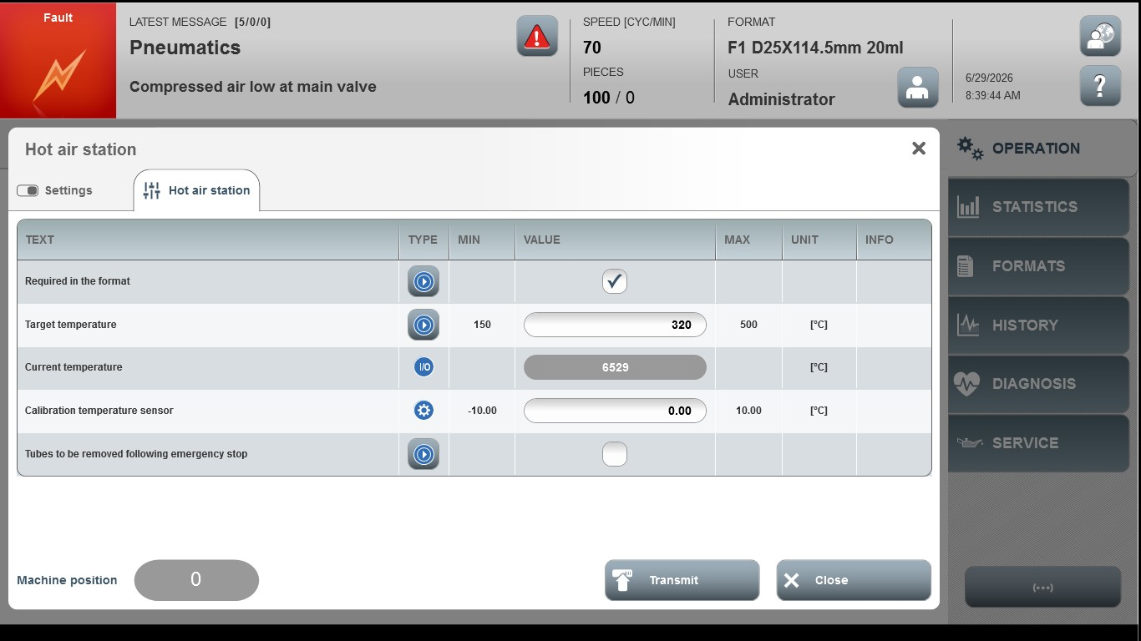
Acceptance criterion | Limits | Pass / Fail: Dev-No. | Date | Initials
Screen matches screenshot | N / A
Target temperature | 150 … 500
Calibration temperature sensor | -10.00 … 10.00

